Step 1:
>> kn – use claude to install Claude Code: https://code.claude.com/docs/en/overview
Claude Code overview - Claude Code Docs
>> add Ccd :\Users\kiatn\.local\bin; to PATH by editing MS System Properties.
Cd to project folder: 2026 Claude coding
Star the Claude by typing “Claude”
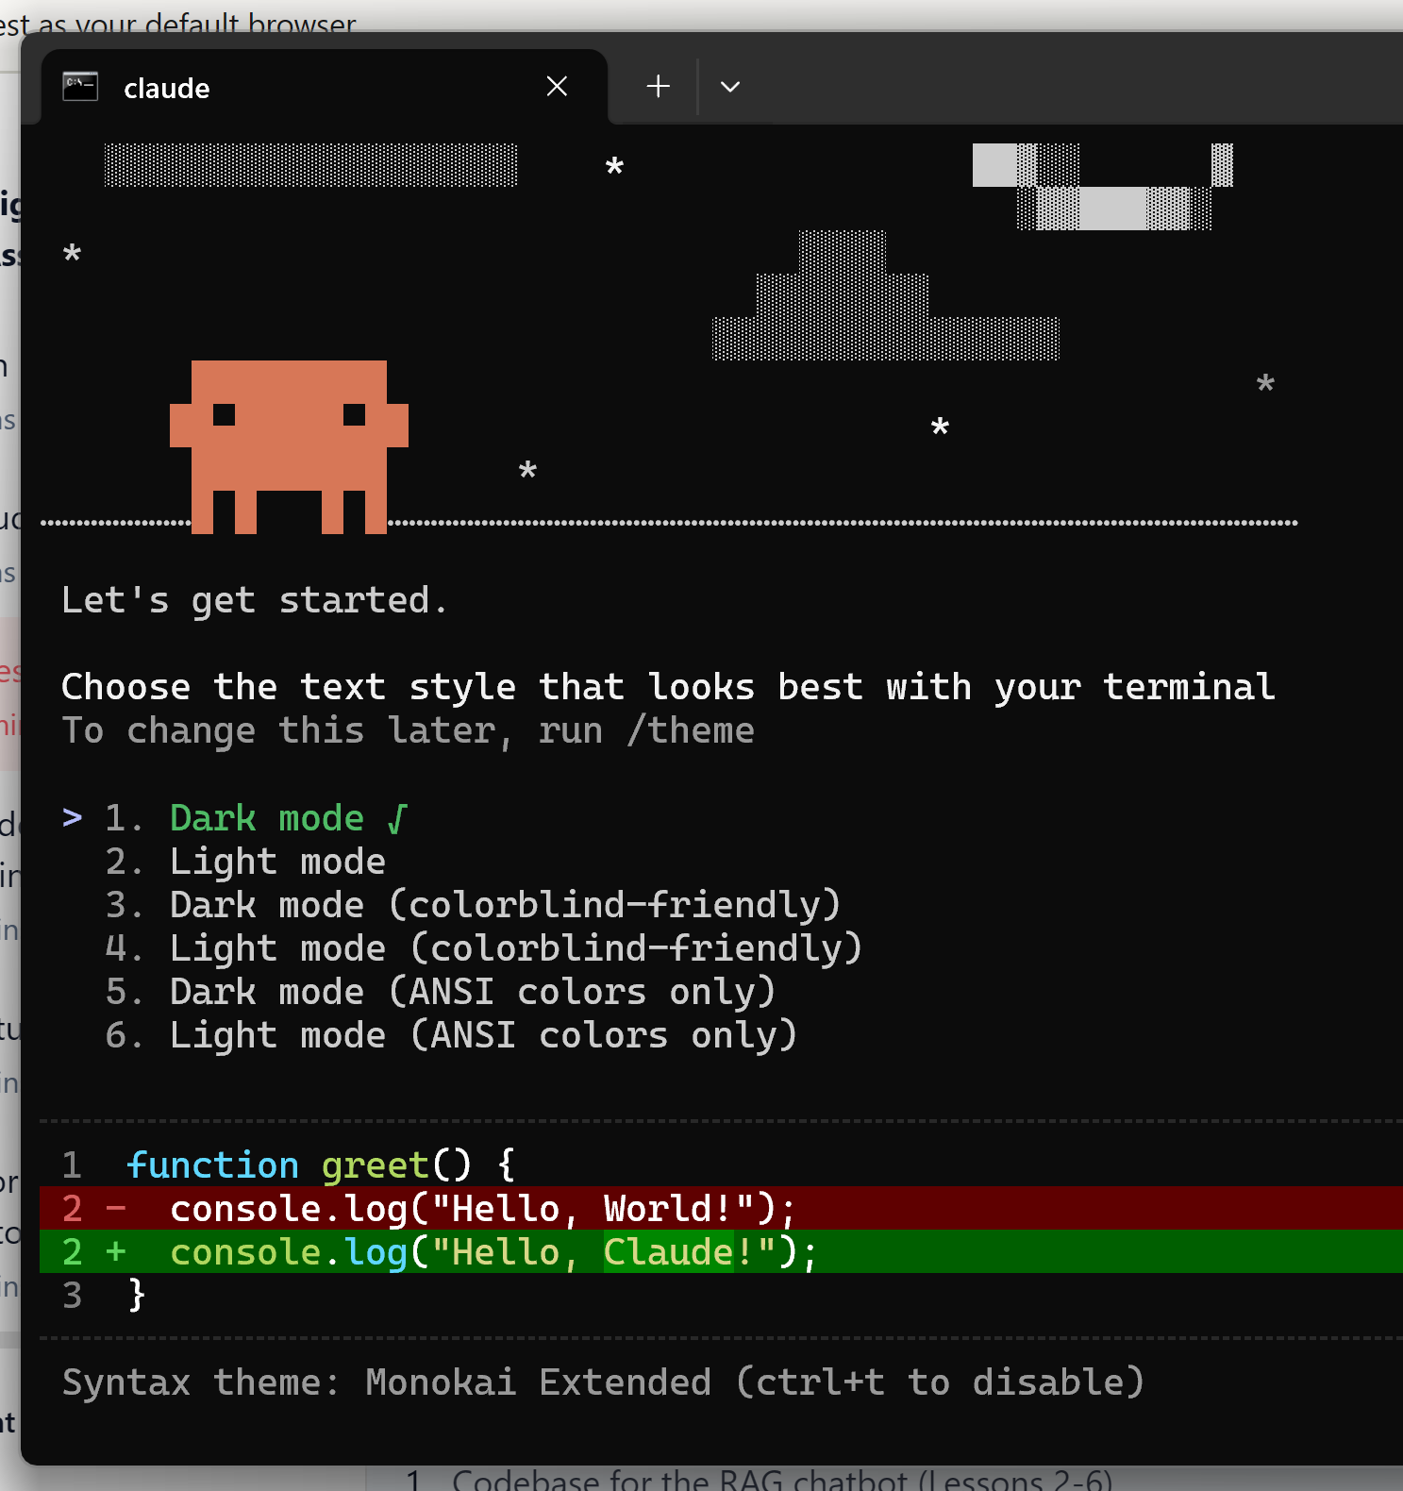

Course Notes
This note includes the instructions on how to install Claude Code, and the links to the coding examples and prompts used in the lessons.
Note:
- To mark this reading item as complete, make sure to scroll down to the end and click on "Mark as Complete".
- There's a second reading item at the end of this course. To get 100% course completion, make sure to also mark it as complete.
Claude Code Installation
To follow along with the lessons, here's how you can install Claude Code.
- Install Node.js, then run:
npm install -g @anthropic-ai/claude-code
For more installation guides, you can find them here. If you're using Windows, make sure to check the Windows Setup here.
- Once you have Claude Code installed, you can:
  - launch it from your terminal: navigate to your project folder & then type claude
  - launch it from the terminal integrated within VS Code by typing claude, the extension will auto-install.
    - If you run into issues, ensure that code command is available. If not installed, use Cmd+Shift+P (Mac) or Ctrl+Shift+P (Windows/Linux) and search for “Shell Command: Install ‘code’ command in PATH”
For more info, check Claude Code IDE Integrations.
Links to Course Codebase Examples
Here are the links to the coding examples covered in the lessons:
- Codebase for the RAG chatbot (Lessons 2-6)
  - Here's the repo of the starting codebase used in lesson 2.
  - Lessons 3-6 add features to the starting codebase.
  - Here's the state of the codebase after lesson 5.
Feel free to fork the starting codebase and follow the lessons' activities.
- E-commerce data analysis (Lesson 7)
  - Here are the lesson's files.
  - It includes the data, the starting and refactored notebooks, and the dashboard file.
Feel free to fork this repo, and try lesson 7 tasks using the starting notebook and the data folder.
- Figma design mockup (Lesson 8)
  - Here's the link to the Figma mockup design (which you can open with Figma Desktop App).
  - In lesson 8, you will build a Next.js app based on this mockup.
  - Here's the link to the repo of the app we got during filming.
Prompts and Summaries of Lessons
You can find the prompts used in each lesson and a summary of Claude Code features in the optional reading item at the end of the course (Prompts & Summaries of Lessons). You can also find them in this repo.
Claude Code Cost
If you'd like to install Claude Code to try the lessons:
- you can use the Pro or Max subscription. The pro subscription is enough for the lessons' activities.
- Or, you can be billed based on API usage. For a given session, you can see the cost using the /cost command.

Get started: Run /init to create claude.md with instructions, code, or files.
From the 2026 – Claude code) project folder – run the /init and create claude.md

Located: C:\Users\kiatn\CLAUDE - Codes

